

SUPERIOR UNIVERSITY LAHORE

GOLD CAMPUS

**NAME:** MUHAMMAD AWAIS ASGHAR

**ROLL NO:** SU92-BSAIM-F24-065

**SECTION:** BSAI-3A

**SUBJECT:** ARTIFICAL INTELLIGENCE

**DEPARTMENT:**SOFTWARE ENGINEER

**ASSIGNMENT NO: 1**

**Loan Prediction Project**

**1. Introduction**

This project aims to predict a loan application will be approved or rejected. By analyzing applicant details such as income, education, credit history, and loan amount, the model provides a data-driven way to support financial decision-making.

**2. Dataset**

Source file: Loan.csv  
Total records: 614  
Key features: Applicant income, co-applicant income, loan amount, loan term, credit history, property area, and others  
Target variable: Loan_Status (Approved = 1, Rejected = 0)

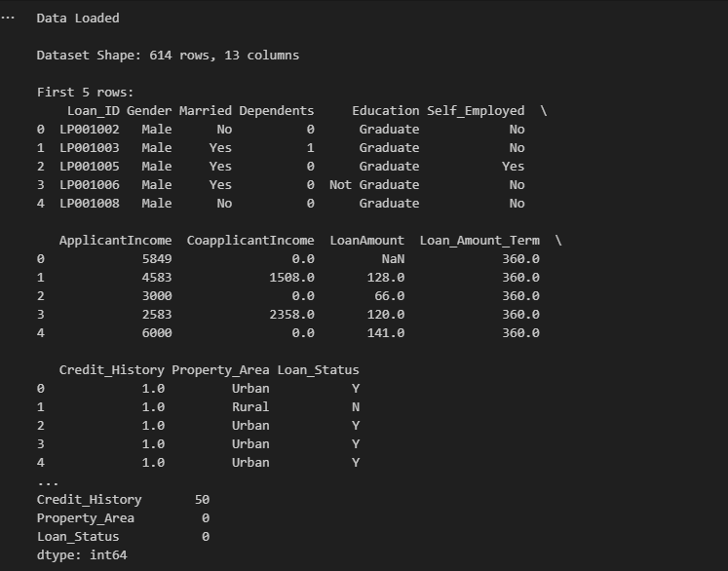

**3. Preprocessing**

To prepare the dataset for training:  
Missing values were handled using forward filling  
Categorical values (e.g., Gender, Education, Property Area) were converted into numeric codes  
Numerical features were normalized using StandardScaler to improve model performance

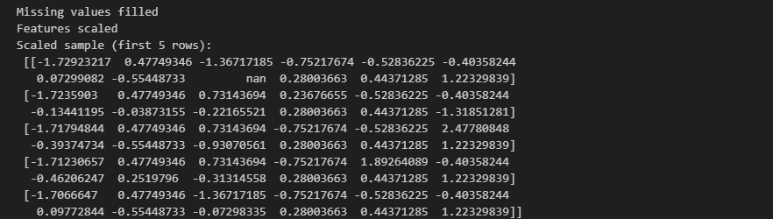

**4. Model Training**

Algorithm: Random Forest Classifier  
Data split: 80% training, 20% testing  
Performance:  
 • Accuracy: around 80%  
 • Confusion Matrix: demonstrated strong prediction capability with a good balance between approvals and rejections

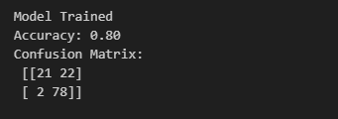

**5. Deployment**

The model was saved as Loan_Prediction_model.pkl along with the preprocessing objects. A Streamlit application was also developed, where users can enter applicant details through a simple interface and instantly get a prediction result (Approved or Rejected ).

